Graphing Inequalities
In this internal we are not only graphing lines that are equal, but we are wanting to graph areas that are more or less than a line to find a ‘feasible region’. This is an area where all of the inequalities hold true. The first one has been done for you.

Question 1  4x + 3y ≤ 120  7x + 8y ≤ 280  x ≥ 5  y ≥ 10 | 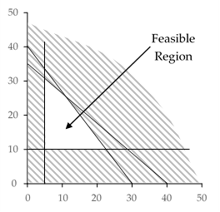
Question 2
12x + 5y ≤ 300
8x + 13y ≤ 520
x ≥ 5
y ≥ 16

Question 3
14x + 9y ≤ 630
8x + 15y ≤ 600
x ≥ 5
y ≥ 10

Question 4
11x + 9y ≤ 495
2x + 3y ≤ 120
x ≥ 11
y ≥ 17

Question 5
18x + 5y ≤ 450
4x + 9y ≤ 360
x ≥ 8
y ≥ 16

Question 6
5x + 2y ≤ 150
5x + 9y ≤ 450
x ≥ 12
y ≥ 11

Question 7
13x + 10y ≤ 650
9x + 19y ≤ 855
x ≥ 19
y ≥ 20

Question 8
3x + 2y ≤ 150
5x + 19y ≤ 475
x ≥ 13
y ≥ 7

